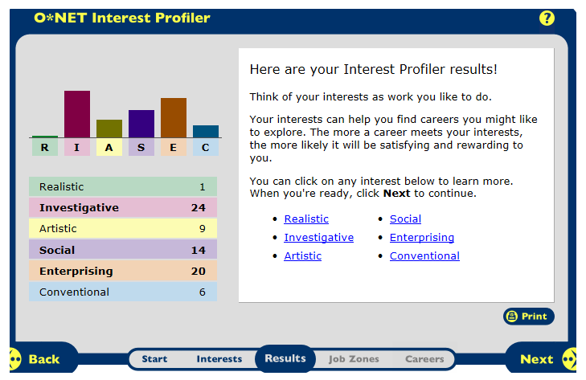

My highest interest result was investigative, then I have enterprising, and the third is social. I think this is a good diagram of my interests.
I think the category Investigative is correct. It involved figuring out problems and that seems like it may be one of my interests.
I would like to take risks for profits and that fits under the category enterprising, which was my second highest. These results make believe I would do well in the bussiness industry.
I think teaching would be fun, and that is under the category social. But I don’t think I want to be a highschool or lower teacher. Maybe a college professor would be an interest of mine.
Jobs:
- Financial Manager
- Public Relations or Sales Manager
- Judge
- Lawyer
- Fitness Trainer
- Postsecondary Teacher
- Loan Interveiwer
- Physician

Career Research Data for 8 Career Occupations
Career Research Questions | Financial Manager | Public Relations or Sales Manager | Judge | Lawyer
HR1. Occupation Definition | A financial manager is responsible for providing financial advice and support to clients and colleagues to enable them to make sound business decisions | A public relations manager creates and maintains a favorable public image for their employer or client | A judge applies the law to court cases and oversee legal process in courts | Lawyers advise and represent individuals, businesses, or government agencies on legal issues or disputes.
HR2. Related Occupations | Securities, Commodities, and Financial Services Sales Agents; Financial Analysts; Top Executives | Advertising, Promotions, and Marketing Managers, Market Research Analysts, Producers and Directors | Lawyers, Paralegals and Legal Assistants, Private Detectives and Investigators | Judges, Mediators, or Hearing Officers, Postsecondary Teachers, Paralegals and Legal Assistants
HR3. Compatible Personality Type(s) | Detail Oriented, Math Skills, Organizational Skills | Research Skills, Speaking Skills, Writing Skills | Critical Reasoning Skills, Decision Making Skills, Listening Skills, Writing Skills Reading Comprehension | Analytical Skills, Speaking Skills, Writing Skills
HR4. Education/Training/Qualifications required | Bachelor’s Degree, 5-Years work experience in a related field, and no on-the-job training | Bachelor’s Degree, Directors: 5-10 Years of Related Work Experience | Law Degree- 4 years of undergraduate study and 3 years of law school | Law Degree, Bachelor’s Degree
HR5. Technology Skills needed | Communications technology because you are working with people and math related technology and financial software | Various Communications Technology | Communications Technology and Microsoft Word to type out evidence and your conclusions | Communications Technology and Microsoft word experience to type out evidence
RC1. Entry Level Average Salary | $103,910 per year, or $49.96 per hour | $57,550 per year, or $27.67 per hour | $91,880 per year, or $44.17 per hour | $112,760 per year, or $54.21 per hour
RC2. 10 yr. Projected Job Growth | 9% Growth (slower than average) | 21% Growth (faster than average) | 7% Growth (slower than average) | 10% Growth (average)
RC3. Organizations that hire for this occupation | Finance and Insurance | Retail trade and Wholesale Trade | State Government and Local Government (excluding education and hospitals) | Legal services and Government
ISC1. Working Conditions | Full time, more than 40 hours a week, at least one third of financial managers work 50-70 hours per week | Full time, one third of Public Relations Managers work 40 hours or more per week | Usually full time, but some judges divide their time between their judicial responsibilities and other careers | Majority work full time, many work long hours
ISC2. Part of a Union? Y/N | No | No | No | No
ISC3. What kinds of Advancement Opportunities are there? | Yes, they may be promoted to management positions; those with extensive experience may start their own consulting firms | Yes, there are opportunities for promotion | Yes, moving to courts with a broader jurisdiction; taking on more cases, starting businesses, and practicing law | After several years of working, they may be admitted to partnership, and become partial owners of the firm they work for; they may become nominated or elected to judgeships
Universities/Colleges/Specialized Training Organizations | -DeSales University  -Dixie State College | -Ashland University  -Augsburg College | -American Public University System  -American University | -American Public University System  -American university

Career Research Data for 8 Career Occupations
Career Research Questions | Fitness Trainer | Postsecondary Teacher | Loan Interveiwer | Physician
HR1. Occupation Definition | A fitness trainer and instructors lead, instruct, and motivate individuals or groups in exercise activities, including cardiovascular exercise (exercises for the heart and blood system), strength training, and stretching | A postsecondary teacher instruct students in a wide variety of academic and vocational subjects beyond the high school level | A loan interviewer/officer evaluates, authorizes, or recommends approval of loan applications for people and businesses | Physicians and surgeons diagnose and treat injuries and illnesses in patients. Physicians examine patients, take medical histories, prescribe medications, and order, perform, and interpret diagnostic tests
HR2. Related Occupations | Physical Therapists, Athletic Trainers, Recreational Therapists | Economists, Political Scientists, Biochemists and Biophysicists | Financial Analysts, Financial Examiners | Dentists, Podiatrists, Optometrists
HR3. Compatible Personality Type(s) | Physical Fitness, Speaking Skills, Problem Solving-Skills | Communication Skills, Critical Thinking Skills, Instructional Skills, Writing Skills | Initiative, Decision-Making Skills, Interpersonal Skills | Detail Oriented, Patience, Problem-Solving Skills, Dexterity
HR4. Education/Training/Qualifications required | High School Diploma or Equivalent, no related work experience needed | Doctoral or Professional Degree | High School Diploma or Equivalent | 4 Years of Undergraduate, 4 Years of Medical school, Doctoral or Professional Degree, 3-8 Years of Internship/Residency
HR5. Technology Skills needed | Know how to use technology related to fitness equipment and various Communications technology | Know how to use Microsoft Word, Publisher, and PowerPoint to teach the class effectively | Know how to operate calculators and other mathematical technology because there is a lot of math involved. Also how to use Microsoft Word because there is a lot of paperwork involved. | Know how to use Data Input and various Communications Technology
RC1. Entry Level Average Salary | $31,090 per year, or $14.95 per hour | $62,050 per year | $33,890 per year, or $15.91 per hour | $166,400 per year, or $80.00 per hour
RC2. 10 yr. Projected Job Growth | 24% Growth (faster than average) | 17% Growth (average) | 14% Growth (average) | 24% Growth (Faster than average)
RC3. Organizations that hire for this occupation | Fitness and Recreational Sports Centers such as the YMCA, WOW, and the Raynham Athletic Club | Colleges | Finance and Personal use | Local hospitals, Private offices, or Clinics
ISC1. Working Conditions | Some work other full-time jobs, and teach fitness classes or personal training sessions during the week or weekend; may work nights, weekends, and holidays | Classes generally in the day, but some are night and on the weekends, most do not work during the summer | Most work full-time, but some who work on commission take on extra clients and have to work longer hours | Long, irregular, and overnight hours; travel between offices and hospitals; while on call, physicians may need to rush to the hospital or nursing home or address a patients concerns over the phone
ISC2. Part of a Union? Y/N | No | Yes, many teachers are in the National Education Association | No | No
ISC3. What kinds of Advancement Opportunities are there? | Yes. They may advance to Head Trainer and become in charge of hiring and overseeing the personal training staff | Yes, a major goal in their career is attaining tenure; a guarantee that they cannot be fired without a just cause | Yes, they may become promoted to branch manager but they may need more education and training | Yes, they can be promoted to larger hospitals with more patients and staff
Universities/Colleges/Specialized Training Organizations | -Adams State College  -Adelphi University | -Adams State College  -Albion College | -Black Hawk College  -California State University: Northridge | -Case Western Reserve University  -Sanford-Brown College: Houston

